Guide to registering on the online tool and starting your Researcher Links application
Step 1 – Make sure you are in the correct link under current opportunities via this link https://www.britishcouncil.org/education/science/current-opportunities for the current call and type of grant you wish to apply for.
This example is for a Newton Fund Researcher Links Travel Grant.
Once you are in the correct link, click on ‘Apply online’.
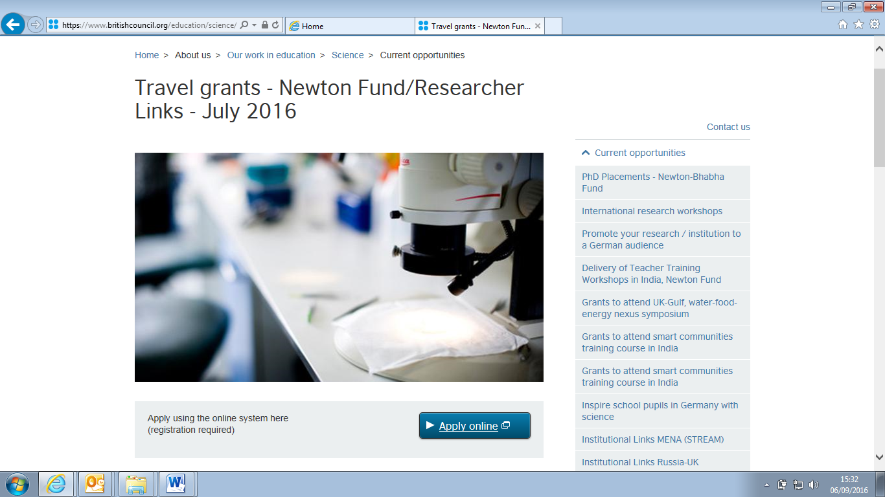
Step 2 – at the next screen, click ‘Register as new user’. (If you are not a new user to this online application tool then please insert your existing email and password and go to step 12).
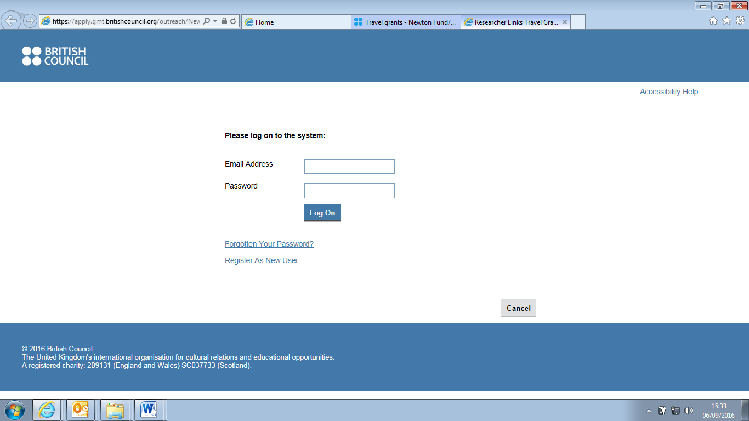

Step 3 – at the next screen fill in your details. Then press OK you will get a notification screen that your registration is complete.
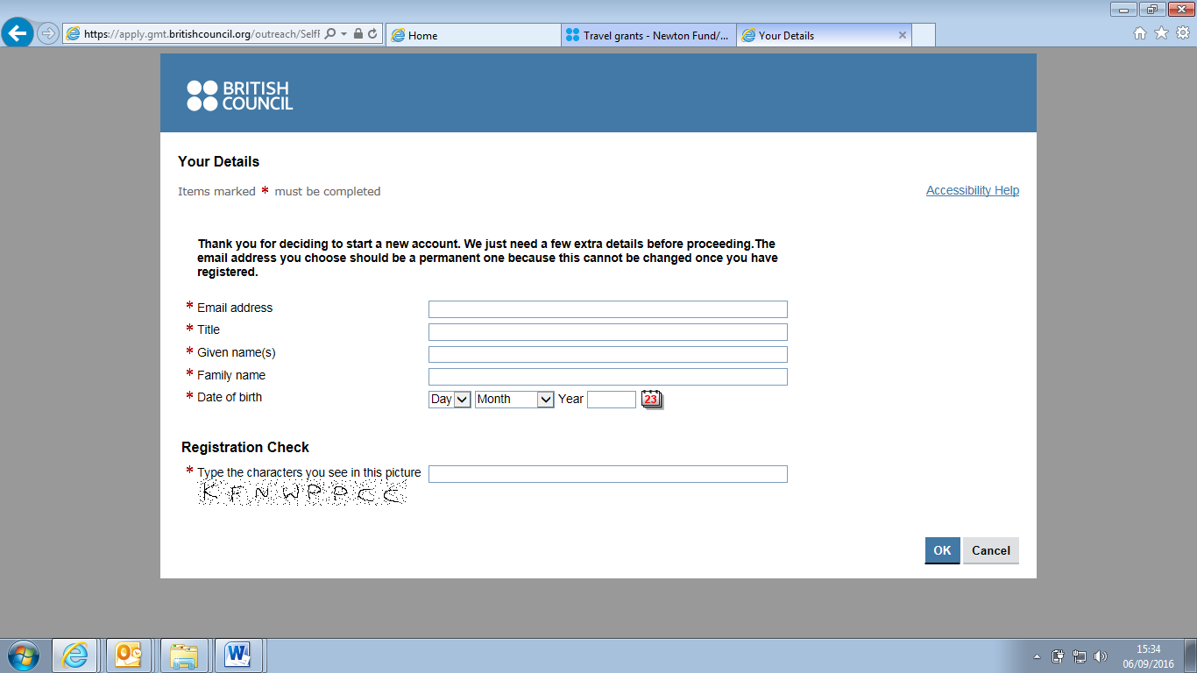
Step 4 – In the ‘Registration Complete’ Screen’ press OK and a mail should be sent to the email address you supplied in step 3 so that you can set up a password.
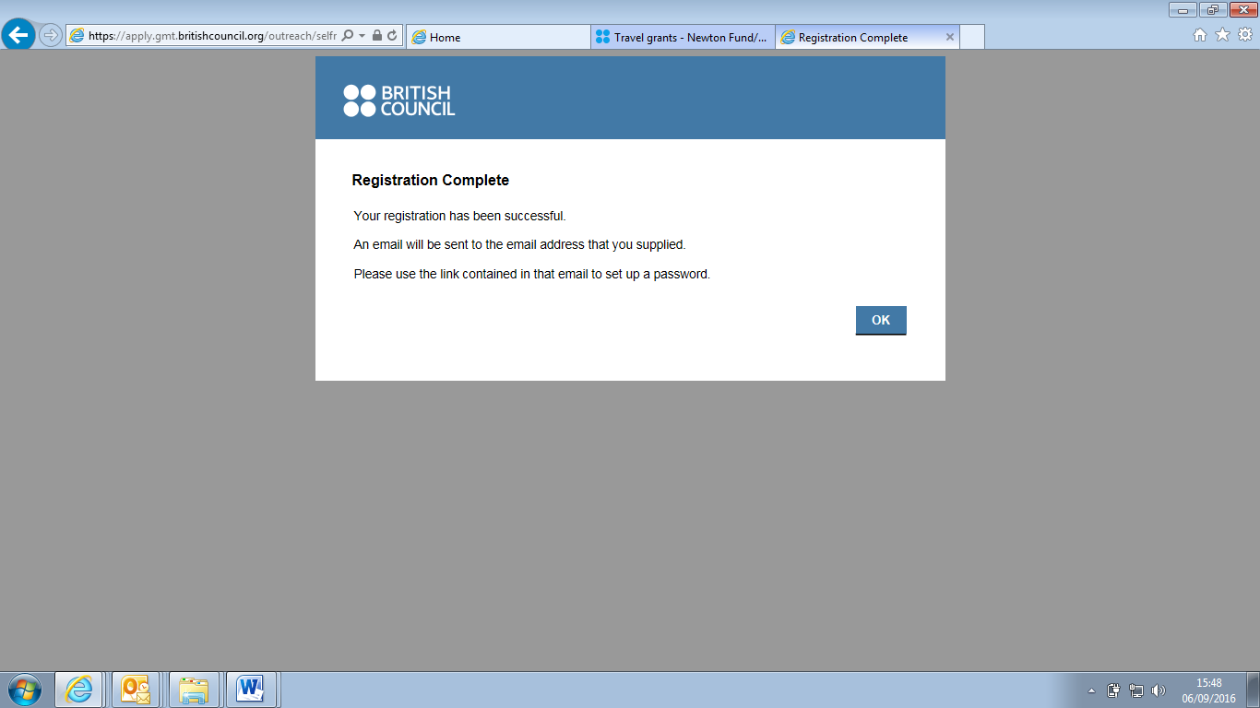
Step 5 – check your inbox, junk mail or spam to see if you received this mail.
Troubleshooting: sometimes with institutional email addresses, the mail goes to Spam. Please check with your IT services to release a mail from applications@britishcouncil.org (see screenshot below to view the mail). Please add applications@britishcouncil.org and UK-researcherlinks@britishcouncil.org to your safe senders list. You will also need to receive other mails from this address once you submit your application.
Then open the link in the mail.
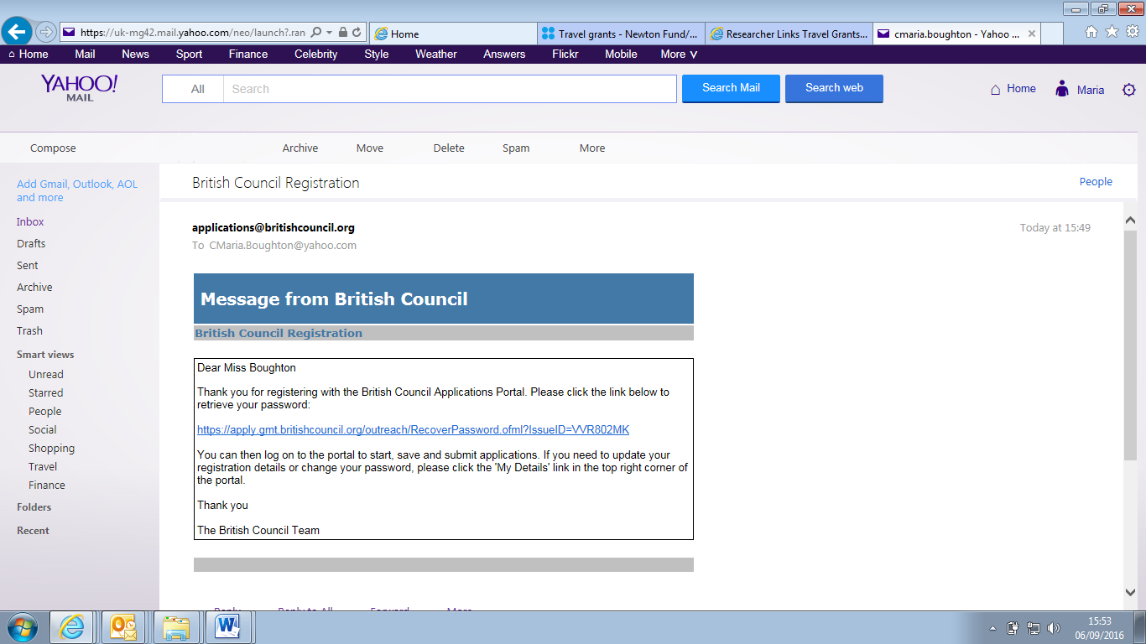
Step 6 – when you have opened the link, press ‘Retrieve password’.
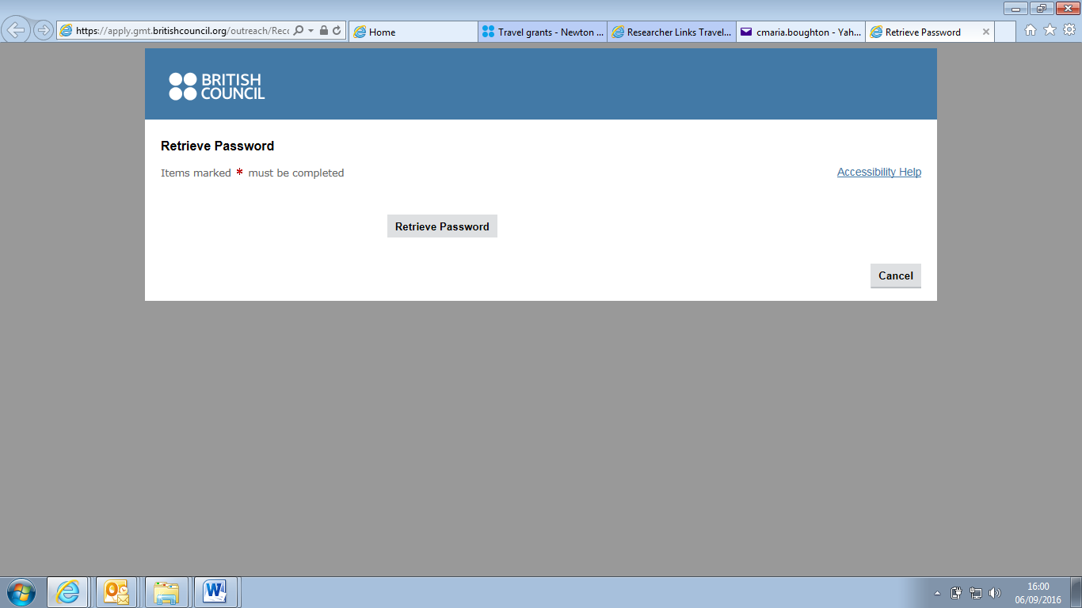

Step 7 – a temporary password is then issued to you. Copy or make a note of the password.
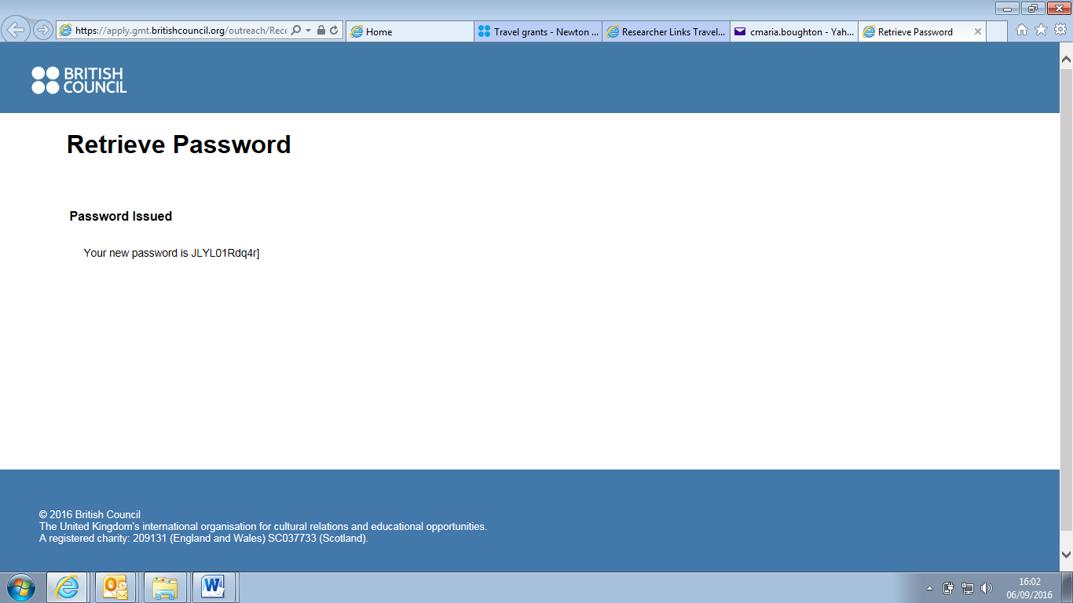
- Return to this screen
- Copy this password
Step 8 – At this screen, copy the given password and return to the Current Opportunities page for the call you are applying for, in this case the webpage for a Newton Fund travel grant. Once you are in the correct link, click on ‘Apply online’.
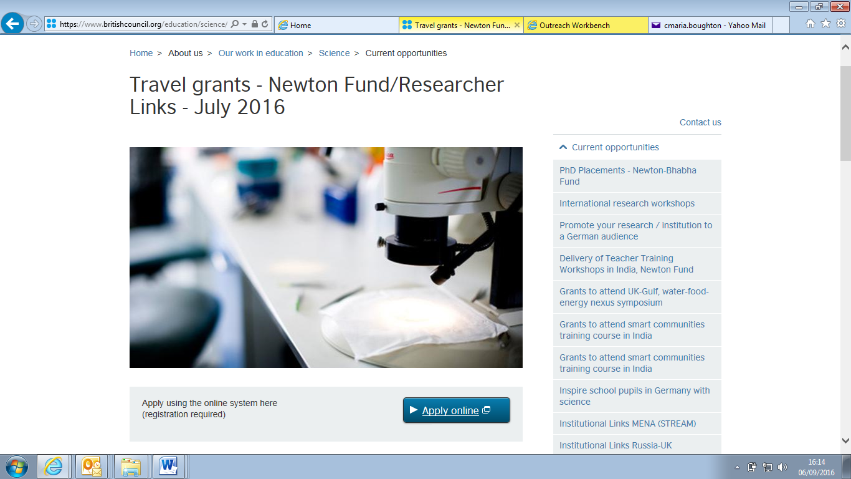

Step 9 - Insert your Email address and paste the temporary password provided to you earlier into the relevant sections and click Log on.
Troubleshooting: If you get an error message after pressing ‘Log On’ at this stage, do not try to re-set your password through ‘Forgotten your password’. Repeat steps 8 and 9 again. If this still does not work, contact UK-ResearcherLinks@britishcouncil.org.
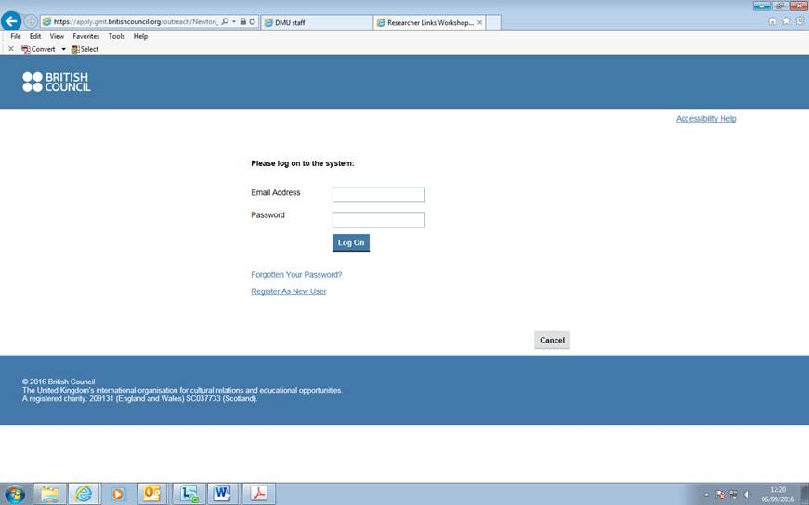
Step 10 - The screen below will appear to prompt you to immediately change the temporary password to a preferred password of your choice. Paste the previously used temporary password into the “current password” field, then insert your preferred password into the “new password” and “repeat new password” fields and click log on.
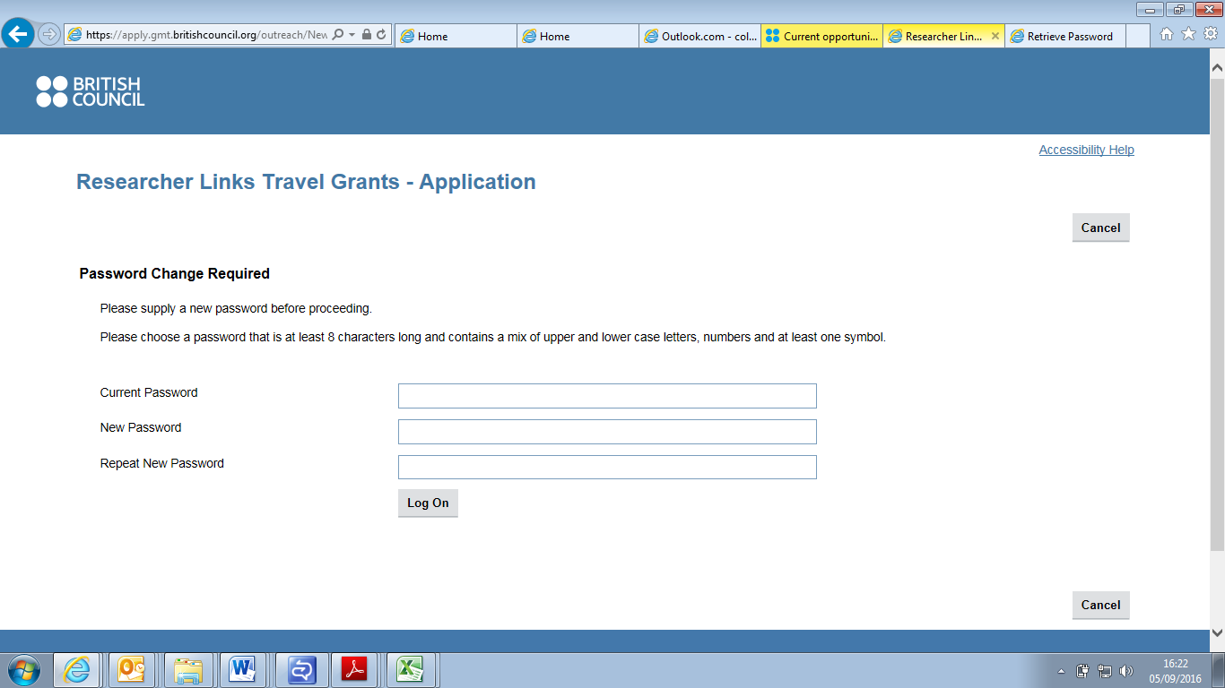

Step 11 – when you press log on in step 10, you should get the following screen:
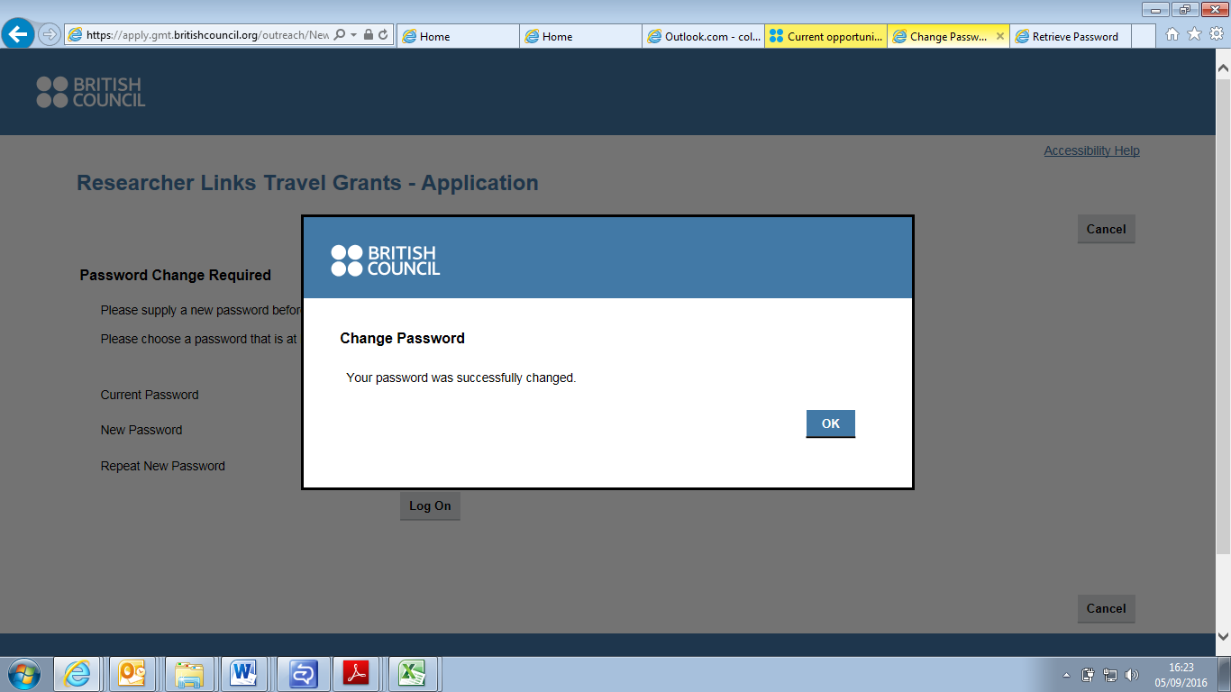
Press OK. Your password has now been changed and from this point onwards your preferred password should be used at all times when logging into your account.
Step 12 – Choose the form for the type of grant you are applying for.
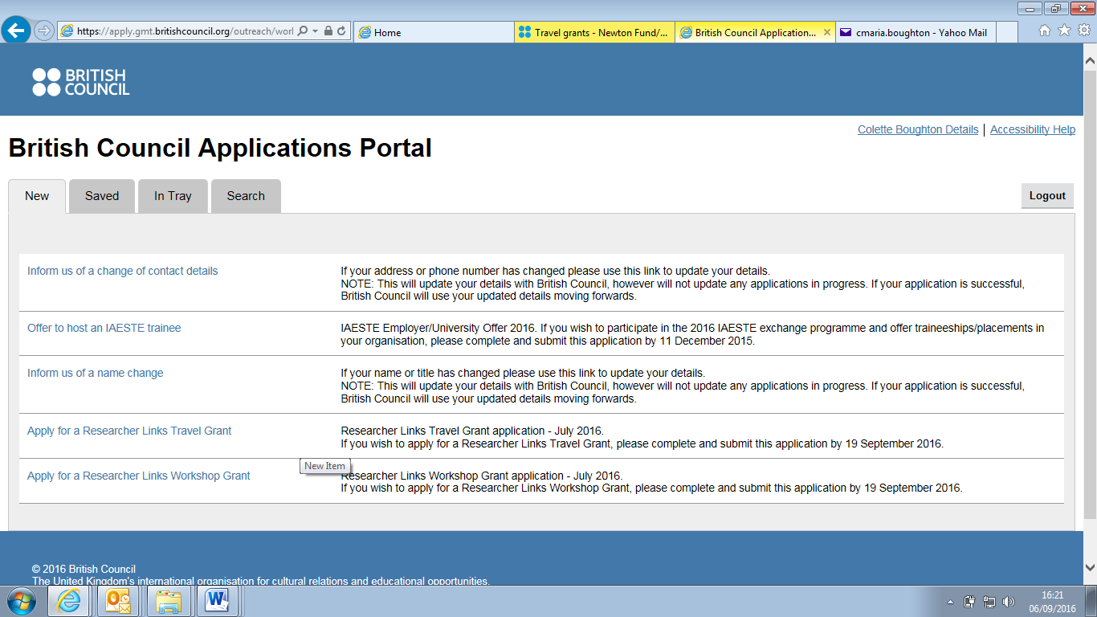
Click on the link for either a Researcher Links Travel Grant or a Researcher Links Workshop Grant depending on the type of grant you are applying for. It is not possible to apply for both types of grant in one call.

Step 13 - You should be taken to the initial page for the type of grant you started applying for. You can then make your way through the application. Good luck with your application!
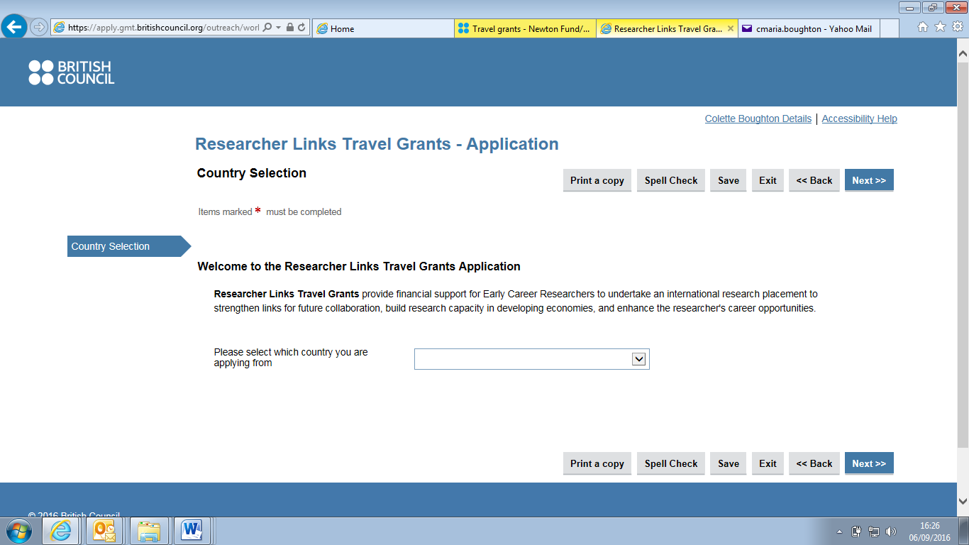
Troubleshooting - Note for trilateral workshop applications:
Following registration, the first page of the form asks for one country, the country in which you are applying from, which is the UK. In selecting the UK it will automatically provide a second selection box for your partner country, please enter one. Move to the next page (Instructions) and at the bottom you will be asked to select if the workshop is bilateral or trilateral. When you select trilateral, you will see that when you move to the next page (Summary Details) it will ask for details of all 3 countries etc. This will be reflected in other areas of the application also as you go along.

